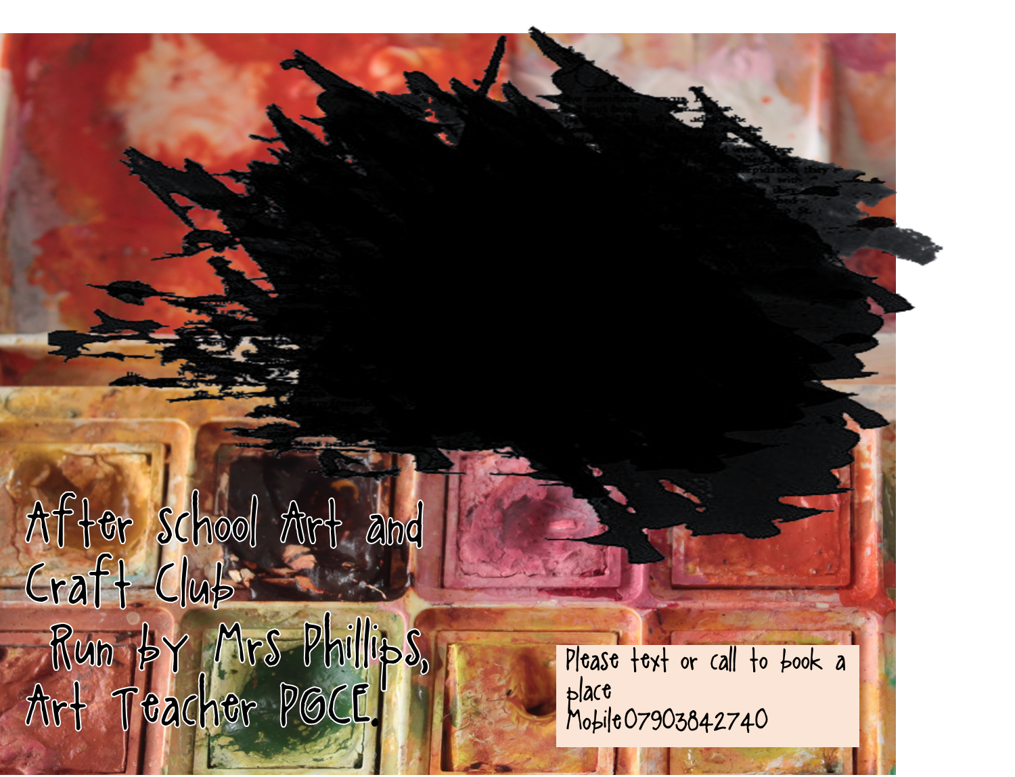

**Wednesday YR3 & YR4**

**Thursday YR5 & YR6**

ART and Craft Club

Cost £4.50 per session including materials.