St. Anne’s

Magazine

Edition One

October 2022

Contents

St Anne’s School

Dog Facts

Mini Vinnies

Class 6 mystery

Fish story

Rabbit Facts

Match the buddies

I know a language

What pupils think about OPAL

Queen’s corgis – what do you know?

Quiz Section

Blob fish colour page

Writers:

*Fraser, Jack, Clodagh, Isabel, Sasha, Monika, Bonnie, Monet, Ellen, Isla H, Isla G, Emelia,, Mabel, Conan, Ethan, Felix and Harry.*

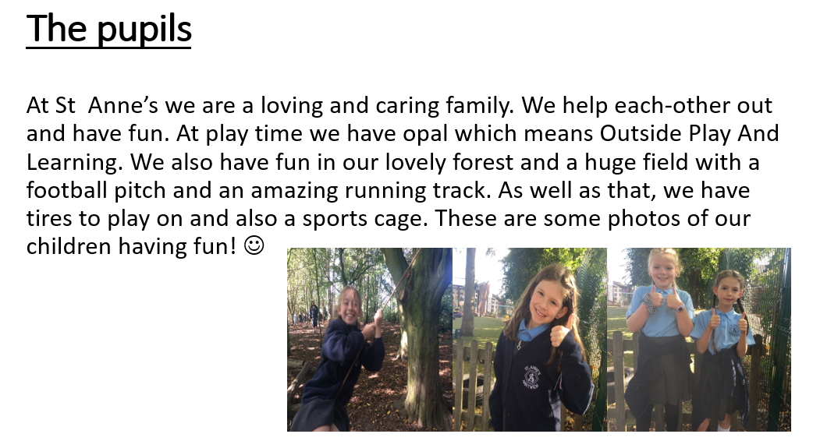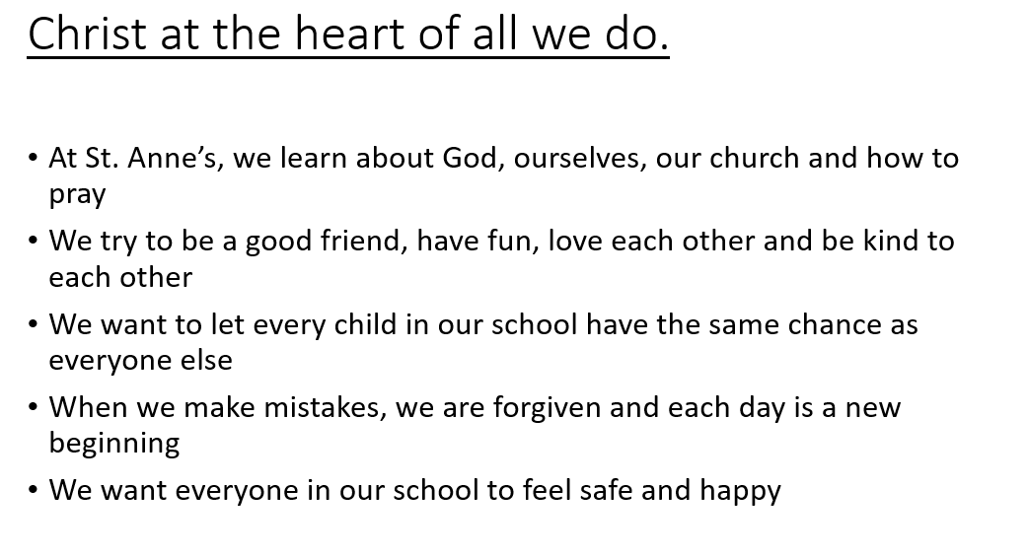St Anne’s School (IG)

Fraser Y5- I think St Annes is a loving place with kind hearted students

Monica Y3-I like that everyone’s kind, caring and loving.

Here at St Anne's we learn about God, our Church and how to pray. We don’t tolerate bullying, racism because we think that every child in our school should have the same chance as everyone else. Everyone at our school should feel safe, happy and have fun. Harvest is coming up so we all bring as much food as we can into school for the food bank ☺ Sometimes children fall out and have arguments but no one in this school is perfect. All of the teachers and pupils are very kind and we help as much as we can ☺ We have a variety of clubs like: Cricket, gymnastics, dodgeball, magazine club and more! It’s never too late to join! (EM)

5 Dog Facts (IH)

Fun facts about dogs

1. Dogs noses are wet to help absorb scent chemicals

This amazing dog fact might answer a long-standing question that dog owners have. Why are dogs noses wet? Vetstreet says that the answer is that dog’s noses are wet to help them absorb scent chemicals! Their nose secretes a special mucus that helps to absorb these chemicals, and then they lick their noses to sample them, helping them understand what the smell is.

Newfoundland is standing in the forest

2. Newfoundlands are amazing lifeguards

Newfoundland dogs are the ultimate doggy lifeguards, because they have water resistant coats and webbed feet. They were originally bred as fisherman’s helpers and to rescue people from drowning.

Some owners have even reported that their Newfoundland tries to “rescue” them when they’re swimming!

3. The Beatles song ‘A Day in the Life’ has a frequency only dogs can hear

In an interview in 2013, Paul McCartney said that he added a frequency only dogs can hear to the end of the Beatles song ‘A Day in the Life’. So watch your dog when you play the song! How’s that for an amazing dog fact?

4. Three dogs survived the Titanic sinking

Did you know that three dogs survived the sinking of the Titanic? Vetstreet states that the dogs were in first class and included a Pomeranian puppy - which her owner wrapped in a blanket to escape with, and everyone thought she was carrying a baby. Another Pomeranian and a Pekingese were also rescued. Move over Rose and Jack!

Bloodhound

5. A Bloodhound’s sense of smell can be used as evidence in court

According to PBS, a Bloodhound’s sense of smell is so spot on that it can be admitted as evidence in a court of law. Now if you thought that was an incredible dog fact, prepare to have your mind blown.



MINI VINNIES (BL)

Mini Vinnies are something we do round school . We organise events like cake sale and charity events . Mini Vinnies come from St Vincent de Paul who helped people all around the world. As mini Vinnies, we don’t have prices for things we sell we let people choose the prises they donate.



Class 6 Mystery (IF, MP)

Class 6 mystery

On Thursday 22nd September 2022 someone stole Isabel’s pencil case the five suspects and only one is the victim.

* Monika- was on the table that Isabel was on, on the day it was stolen. She has blond hair, blue eyes and is a girl.
* Monet- took the pencil case to borrow her pens on the day it was stolen. She is brown hair, green eyes and is a girl.
* Bonnie- moved the pencil case for SASTs practise on the day it was stolen. She has brown hair, blue eyes and is a girl.
* Jack- knocked the pencil case, on the day. He has blue eyes and is a boy.
* Clodagh- had a falling out the day it was stolen. She has blond hair green eyes and is a girl.

Clue one

Left behind was a few numbers written on the table (watch out for the angry teacher she still can’t rub it off) one suspect.

The number is so the person with blond hair is no longer a suspect.

Clue two

Unscramble the words so you can find the description of their hair (there will be ones to trick you!)

igeht

tuhrt

owrbn

lettil

Clue three

Two people left who shall it be? You have to run around the golden mile 5000000 times, only kidding. You have to figure out this. The word in red is ether a noun which means Bonnie. If it is a verb it is Jack. A little girl skipped to school but she was late.

(Answer given in the next edition)

Fish Story

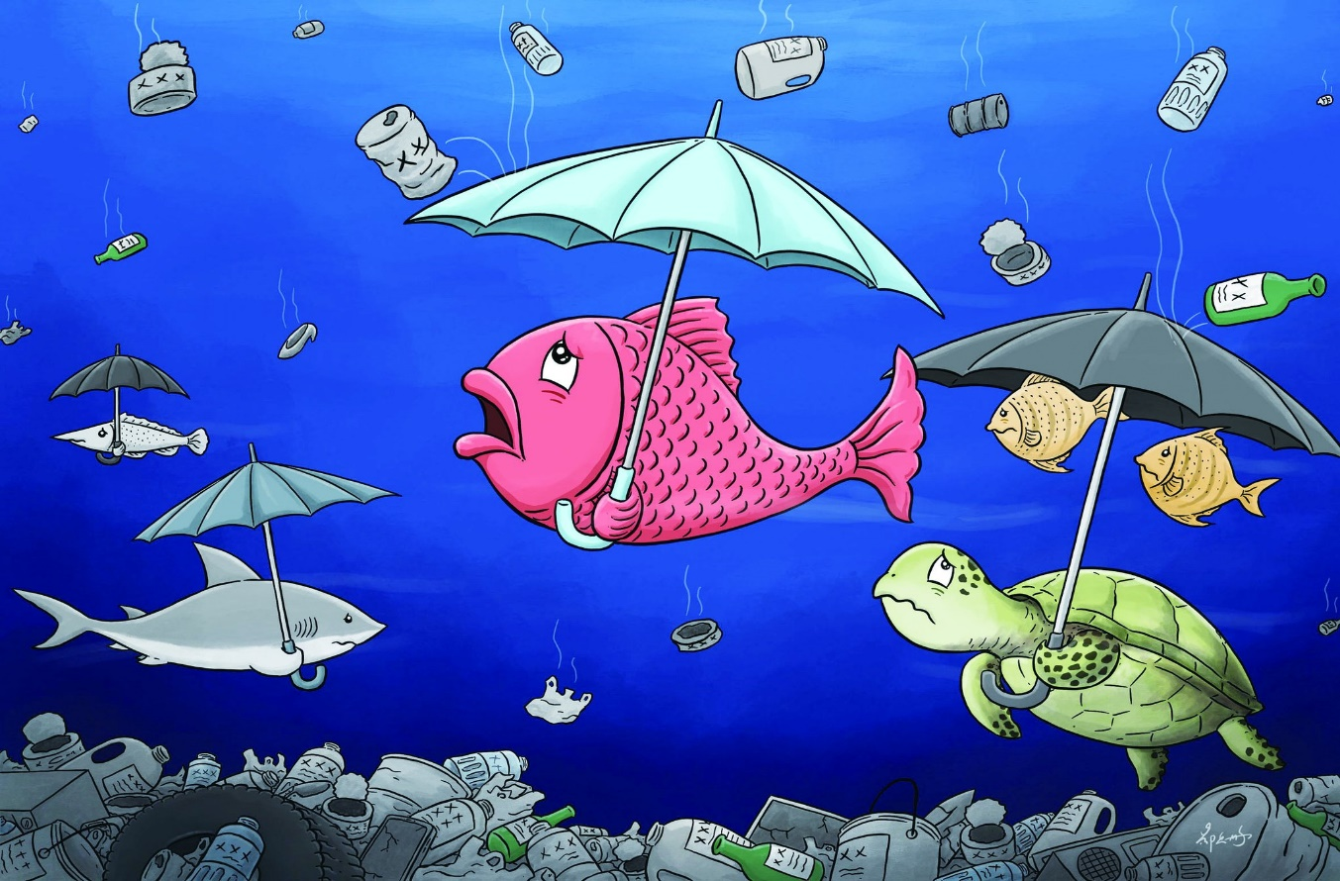

Fishies story.

Fishie is a young and adventurous fish he lives in a dark and scary place. It USED to be a lovely bright and colourful place .

BUT BECAUSE OF OCEAN POLLUTION THINGS HAVE CHANGED. FISHIE NOW HAS TO SHELTER HIMSELF FROM ALL THE PLASTIC AND OTHER RUBBISH. HELP FISHIE AND HIS FRIENDS .

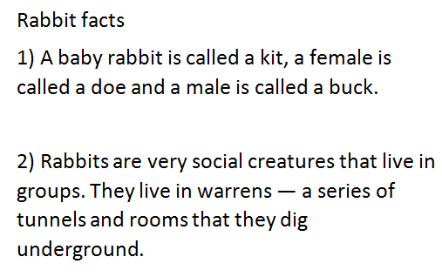Rabbit Facts (IH)

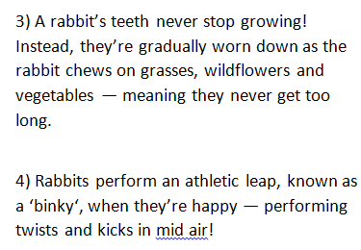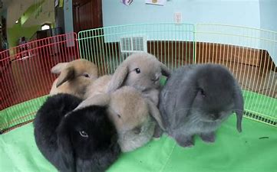

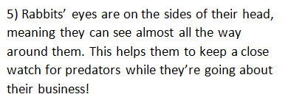

**MATCH THE BUDDY TO THE BUDDY**

First one to match the buddy to the buddy and brings it to Isabel in year 6 wins a price!!!!!

Good luck!!!

|  |
| --- |
| Isabel Somi-k  Bonnie Indi  Jack Emily  Clodagh Marsia  Freya Nousica  Monika Reyne  Monet Timmy  Rory Ava |



**I know a language**

Repeat these sentences in as many different languages as you can.

1. Hello and welcome to St Annes

1. Literacy is great fun
2. I like Maths

***What do pupils think about OPAL play? (EJJ)***

St Anne’s is an amazing school because we are kind and loving to each other . St Anne’s and OPAL are working to make St Anne’s playtimes better . Let’s look at the interviews to see if Opal has made our playtimes better:

Mabel : she thinks it has made ST Anne’s playtimes better and her favourite piece of equipment is the suitcases. ☺

Isla .G : she thinks it has made ST Anne’s playtimes a lot better and her favourite piece of equipment is the tyres.

Isla .H: she thinks it has made a huge improvement and her favourite Opal playtime thing is the forest.



**The Queen’s Corgis – what do you know? (SC)**

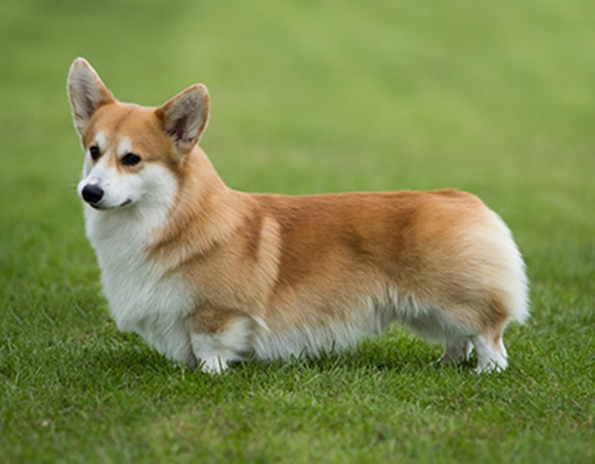FACTS

ABOUT CORGIS

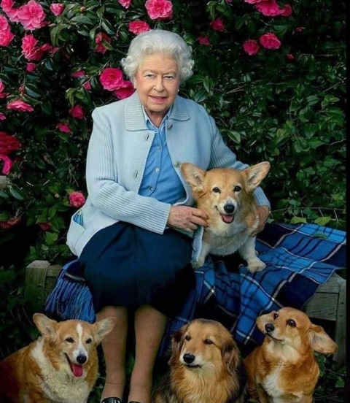You’ve probably heard of a corgi, but what do you actually know about them? Well why don’t you find out!

* Fond of corgis since she was a small child, Elizabeth II owned more than 30 corgis.
* The Welsh Corgi is known as one of the most agreeable of small house dogs and is a loyal, loving pet for families.
* Corgis are known for their intelligence and enthusiasm for working. Many of them compete in dog sports.
* Corgis are rated as the 11th smartest breed in **Stanley Coren's book The Intelligence of Dogs.**
* 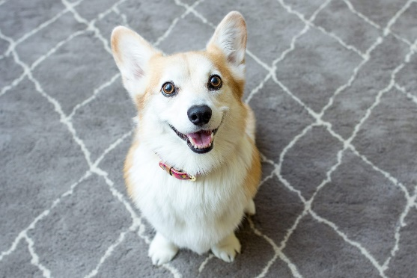They are really cute!!!

**Quiz Section**

**The first one to get the answer of these questions back to Monika and in year 6 wins a prize!!**

**Who was the first man to walk on the moon?**



**When did the fire of London start?**

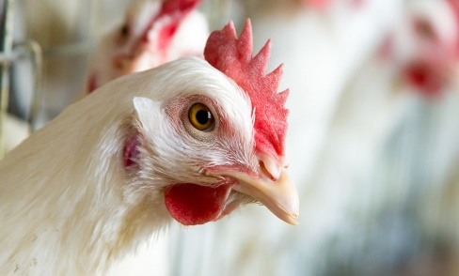

**Are there more chickens than humans?**

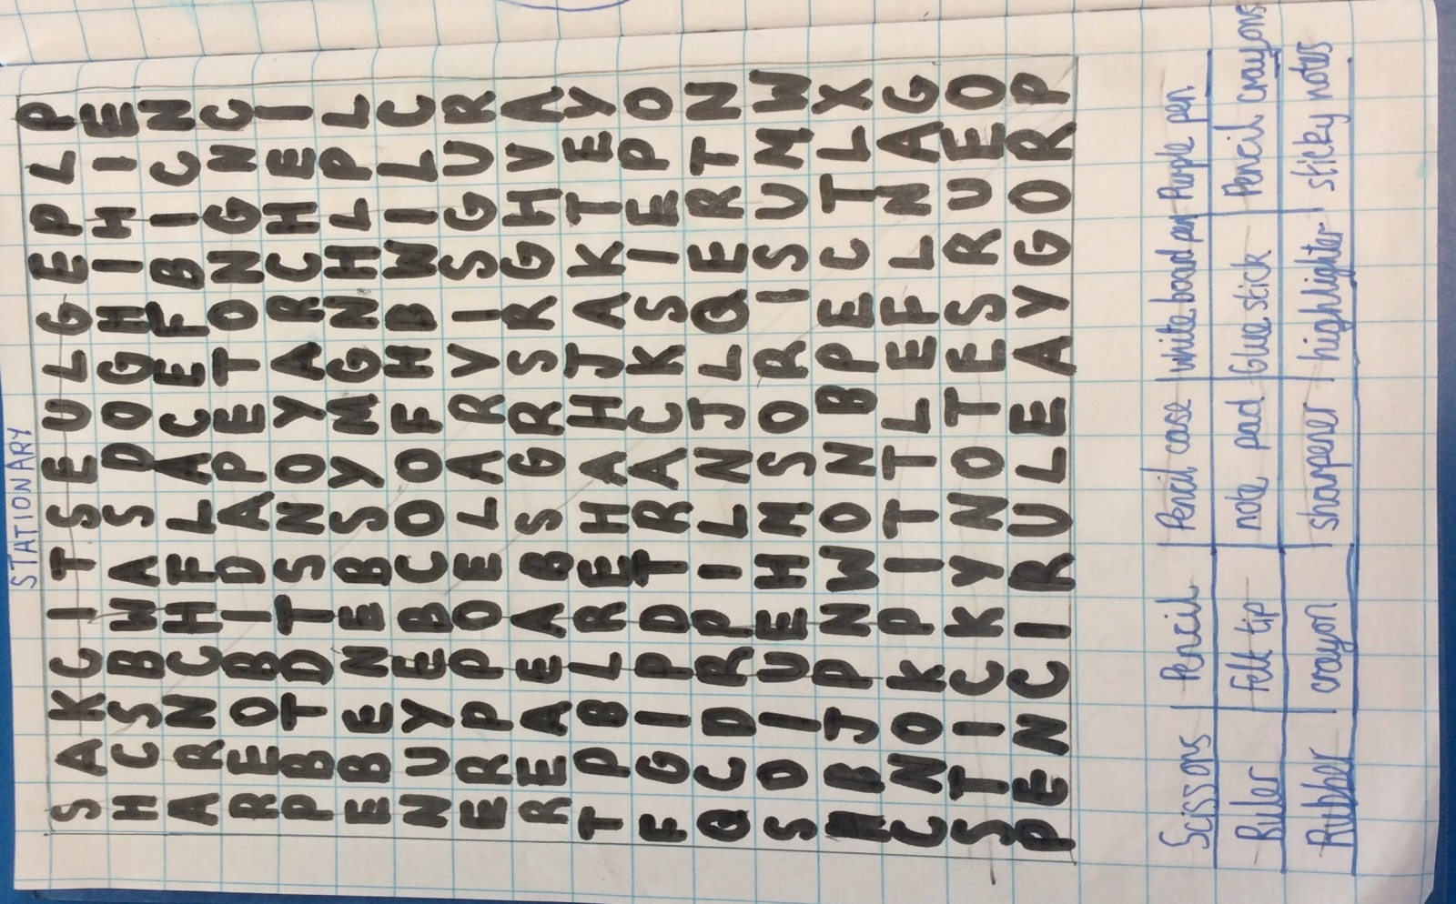

|  |  |  |  |  |  |  |  |  |  |
| --- | --- | --- | --- | --- | --- | --- | --- | --- | --- |
| p | e | n | c | i | l | a | s | d | f |
| g | e | h | j | k | c | l | g | w | e |
| r | t | n | y | r | u | o | l | p | z |
| s | x | c | a | v | b | n | u | m | c |
| a | s | y | d | p | a | p | e | r | f |
| h | o | j | k | l | q | e | w | r | t |
| n | r | t | y | u | y | o | p | a | z |
| r | u | l | e | r | b | n | d | s | e |

Pen glue

Paper pencil

Ruler crayon

BOB FISH colouring page



