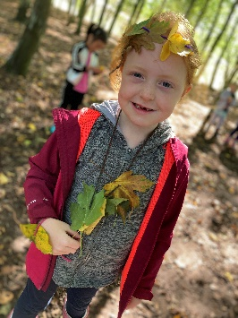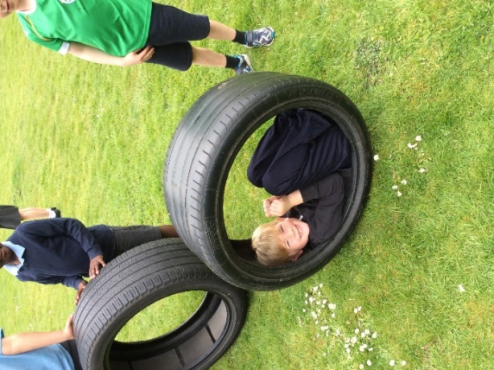OPAL NEWSLETTER WINTER 2022

**Welcome to our first OPAL newsletter!**

Every half term we will send out a newsletter updating you on all of the exciting things we have been up to during break times.

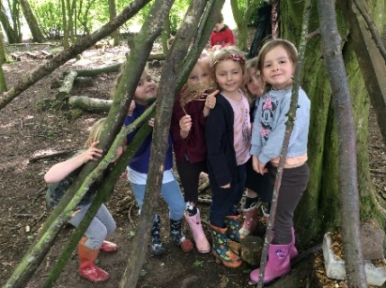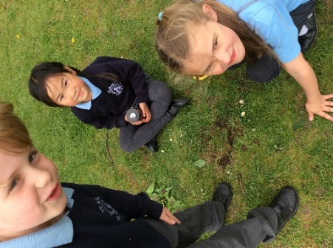

Thank you to all our parents who have already sent in wellies and outdoor coats for your children. This is a vital part of our project which will enable the children to use more of our site, whatever the weather!

Every day we see something different happening outside. Please take the time to ask your children about their play. They may surprise you with their ideas!!

The bad weather brings with it new challenges for outside play.

BUT…. We continue to inspire imagination and put our children’s play at the heart.

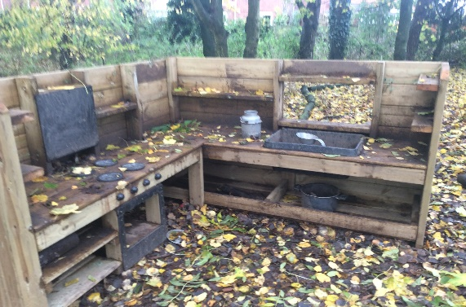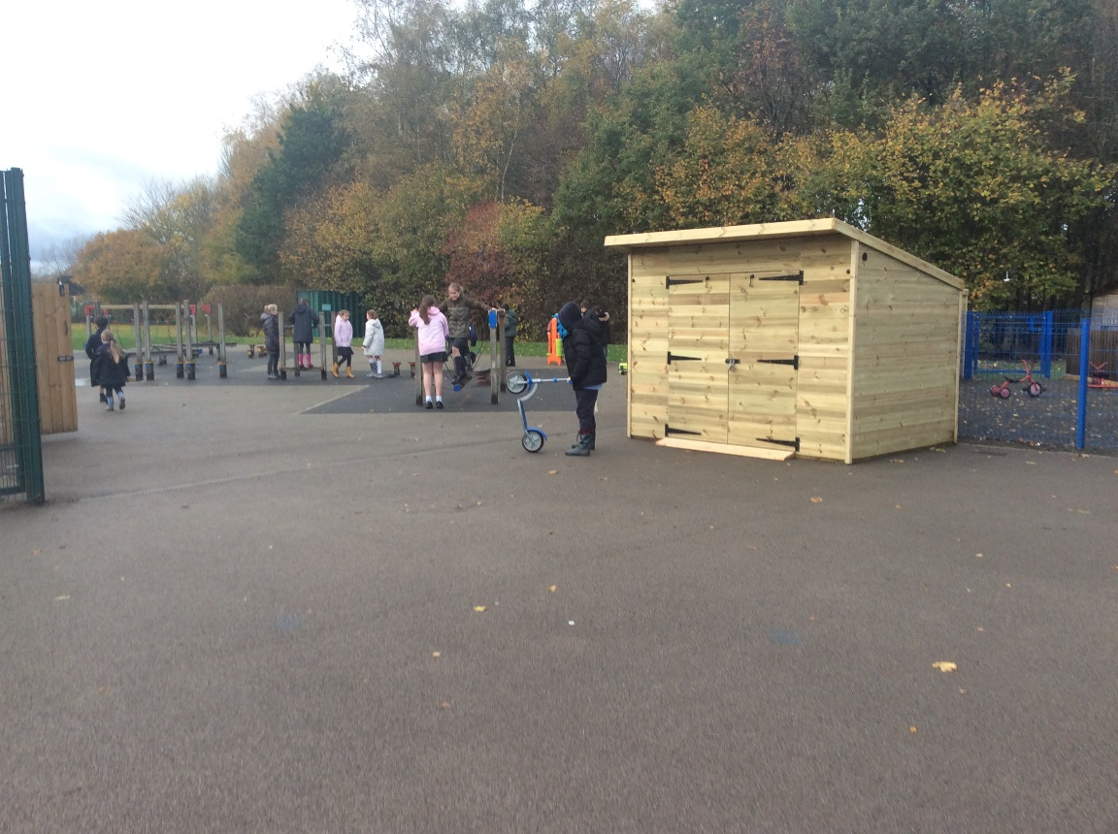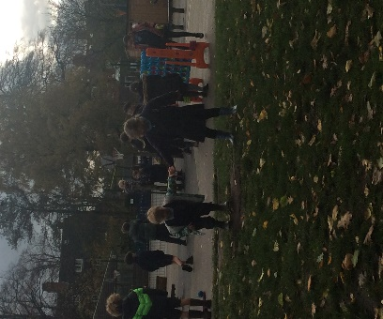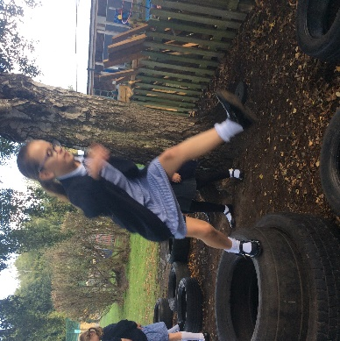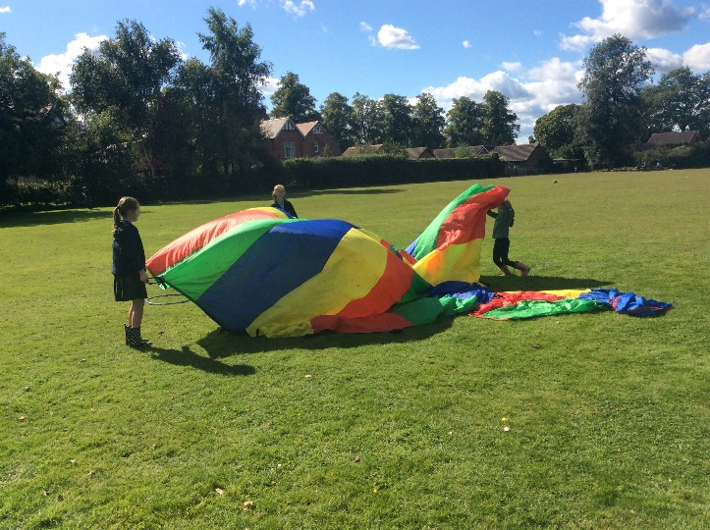

Our new mud kitchen!

**New storage sheds!**

Our new storage shed has arrived!

We can’t wait to fill it with fantastic resources.

We are always on the lookout for resources!

If you have or know anyone who has:

* **Pots/pans**
* **Suit cases**
* **Cones**
* **Tyres**
* **Netting**
* **Dressing up clothes**
* **Gardening equipment**
* **Milk crates**
* **Road signs**
* **Large pieces of fabric**
* **Guttering**
* **Noodles (type used for swimming)**

**ANYTHING**

(*all resources must not be broken, must be safe for children to use)*

Mud is GOOD!

**Coming soon…** look out for music making!