Catholic Primary School
RE Newsletter 2


Dear Parents,
The dark nights have certainly found their way back to us and we return from half term to the month of November – a time to remember those who have gone before us into the loving embrace of God.
We also find ourselves moving towards the season of Advent when we prepare to celebrate the birth of Jesus, the Son of God, at Christmas.
Eternal rest grant unto them O Lord, and let perpetual light shine upon them. May they rest in peace. Amen

In this issue of the newsletter you will find what your child is learning about in each year group. We hope you find this newsletter of interest and as always, please keep us in your prayers as we continue to support your children in their religious education.

Dates from the Church’s calendar:
1st November All Saints’ 7th December St. Ambrose
2nd November All Souls 8th December Immaculate Conception
11th November St. Martin 13th December Third Sunday of Advent
21st November Presentation of Mary 14th December St. John of the Cross
22nd November Christ the King 20th December Fourth Sunday of Advent 23rd November St. Columban 24th December Christmas Eve
29th November First Sunday of Advent 25th December Christmas Day
30th November St. Andrew 26th December St. Stephen, first martyr
3rd December St. Francis Xavier 27th December The Holy Family
6th December Second Sunday of Advent

Nursery & Reception – God’s Family
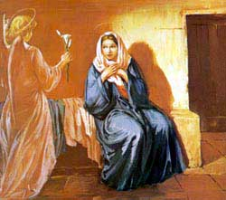

“Creation is the first and universal revelation of God’s love … Each human person
is made in God’s image …”
Religious Education Curriculum Directory
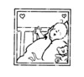

This half term, the children in the Nursery and the Reception classes will be learning about God’s Family. Throughout the topic, the children will be given opportunities to become aware that God made all the people in the world to be part of his family and that we are part of it too.

They will learn that God made us to know and love him, as well as to show our love for him by helping one another. They will find out that God has given us gifts so that we can show his love to others.
As Christmas approaches, they will learn that God’s greatest gift to us was to send his only son Jesus and learn how to respond to that gift.
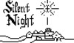
At home
You could help your children by:
• reminding them that Christmas is about the gift of Jesus to us and not just about receiving presents.
• talk about your family and draw pictures of Jesus being part of your family
• take them to see baby Jesus at church during the Christmas season.

Year 1 – Mary, the Mother of God
The children will learn that God sent the Angel Gabriel with a message
to Mary and learn why this is important. They will learn that God asked
Mary to be the mother of his son and will have an opportunity to reflect
on her response.

They will hear about Mary’s visit to her cousin, Elizabeth and reflect on the good news. They will begin to reflect on how we can prepare to celebrate the birth of Jesus and learn that Mary is our mother in heaven and that she is looking after us.

At home
You could help your children by:
• reinforcing why Mary is important for Christians
• discussing the importance of mothers

Year 2 – Mysteries
“God is one and God is Three, a Trinity of persons: Father, Son and Holy Spirit”
Religious Education Curriculum Directory
The children will learn about and reflect on mysteries. They will be encouraged to say and reflect on what they wonder about. The children will learn that there are three persons in one God and that we can experience God in three different ways as Father, Son and Holy Spirit.

They will learn about and reflect on God’s choice of Mary and Joseph and know that Jesus is God’s gift to the whole world.

At home
You could help your children by:
• reminding them, as they make the sign of the cross, that God is Father, Son and Holy Spirit
• reading the Christmas story and encourage them to ask questions

Year 3 – Mary our Mother
“Mary the Mother of Jesus and therefore the Mother of God is the first disciple…She is the Church’s model of faith and charity and because of her singular response to God’s Word is Mother of the Church.”
Religious Education Curriculum Directory
The children will learn that God called Mary to be the Mother of Jesus and learn how Mary responded to God’s call. They will learn the ‘Hail Mary’ and begin to understand what the words mean.
They will learn that Advent is a time to prepare for the coming of Jesus at Christmas and begin to understand that Christmas is a celebration of the birth of Jesus, the Son of God. They will also learn about the stories of the shepherds and the wise men’s visit to see the baby Jesus.
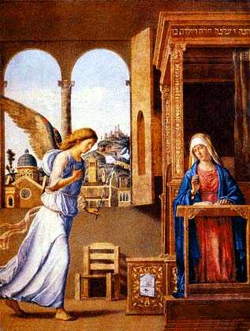

At home
You could help your children by:
• saying the ‘Hail Mary’ everyday
• talking with them about the importance of Mary in Jesus’ life
______________________________________________________________________

Year 4 – Trust in God
The children will learn about Jesus’ teaching and the importance of trusting in him. They will learn that it is not always easy to trust in God (e.g. Zechariah).
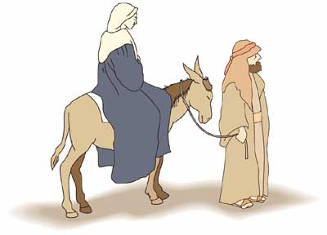

They will learn about the promise God made to Mary through the angel Gabriel and
learn how Joseph put his trust in God when the angel appeared to him. They will
become familiar with Mary’s song of praise and trust in God (the Magnificat) and
learn that God fulfilled his promise to Mary when Jesus, the Son of God, was born.

The children will have a chance to deepen their awareness of God’s love for us and know that he asks us to trust in him. They will reflect on the times it is difficult to trust and on the importance of keeping promises. They will make their own Advent promises. The children will reflect on how Mary and Joseph placed all their trust in God and experience a celebration of the Nativity.

At home:
You could help your children by:
• making an Advent calendar with them

Year 5 – The Commandments
At home:
The children will learn that God loves us You could help your children by:
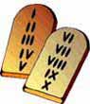
and calls us into friendship with him. • talking to them about how we
try to live by the Ten
Commandments.

The children will understand that the Ten Commandments are a gift from God to help us.
They will learn how Jesus summarised the Ten Commandments (Matthew 22: 36-40) and begin to understand how we can show our love for God by keeping his commandments with his help.

The children will also learn that God sent his Son Jesus into the world because he loves us, and that we celebrate this gift at Christmas.

Year 6 – Justice
“Love of neighbour … involves working for a just society, both locally and internationally”
Religious Education Curriculum Directory
The children will learn that God called the prophets from the Old Testament and learn about the different ways they responded. They will learn that the prophets spoke out against injustice and that some prophets were persecuted because they spoke out.

They will learn that Christians are called to work for justice and find out about individuals who have been persecuted for speaking out against injustice.

The children will learn that Advent is a time of waiting and hoping for the birth of the Messiah at Christmas and understand that the birth of Jesus fulfilled Old Testament prophecies.
At home:
You could help your children by:
• thinking about how your family could support the work of CAFOD
• visit www.cafod.org.uk to learn more about CAFOD and its work in the developing world
• include an intention for people fighting injustice in your prayers with the children.

