St Anne’s Catholic Primary School
RE Newsletter 1
Dear Parents,
Welcome back to the new academic year. Below you will find information about what your children will be learning in their Religious Education this half term.

Dates from the Church’s calendar:
3rd September St. Gregory the Great 7th October Our Lady of the Rosary
4th September St. Cuthbert 9th October St. John Henry Newman
8th September Our Lady’s Birthday 10th October St. Paulinus of York
14th September Exaltation of the Cross 12th October St. Wilfred, Diocesan patron
15th September Our Lady of Sorrows 13th October St. Edward the Confessor
21st September St. Matthew, Apostle 15th October St. Teresa of Avila 24th September Our Lady of Walsingham 17th October St. Ignatius of Antioch
29th September Ss. Michael, Gabriel & Raphael 22nd October St. John Paul II, Pope 30th September St. Jerome
1st October St. Therese of Lisieux
2nd October Guardian Angels

Throughout Ordinary Time: Autumn we are asked to pray for the following intentions:
The Harvest - the Fruits of Human Work - and the Reverent Use of Creation
Students and Teachers, The Spread of the Gospel, Justice and Peace in the World, Prisoners and their Families, All Victims of War, Young People

Reception – God’s World
“Creation is the first and universal revelation of God’s love”
Religious Education Curriculum Directory

This half term, the children in the Nursery and the Reception classes will be learning about God’s world. Throughout this topic, the children will begin to appreciate the beauty of the world and know that God made it.
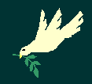
They will learn that God loves and cares for each one of us and reflect on this. They will hear about and respond to the things God created for us.

They will know that God has asked us to care for the world and think of ways in which we can
help to do it.
At home
You could help your children by:
• looking at pictures of animals and plants and talking about how special creation is
• encourage them to notice different parts of God’s wonderful creation and think of ways to care for the world.

Year 1 – God’s Great Plan

“As the first action of Father, Son and Holy Spirit, creation is the first step towards the covenant relationship God seeks with every human being”
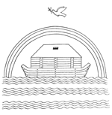
Religious Education Curriculum Directory

The children will learn about the beauty of God’s world and explore and respond to the wonders of creation e.g. the seasons. They will also hear about the story of Creation from
Genesis and talk about its meaning.

They will be reflecting on the knowledge that God made us because he loves us and develop
their understanding that we show God we love him by looking after the world and each
other. They will learn that we can spoil God’s creation and that we have a responsibility to look after it, as well as hearing an appropriate part of the story of Noah and the Flood and its message of salvation and hope.

At home
You could help your children by:
• talking about how we can look after the world, e.g. recycling, not dropping litter, conserving energy and how we can care for plants and animals
• look at the trees during the autumn season and talk about the different colours. You could collect leaves to make a collage or painting.

Year 2 – The Chosen People
“In order to gather together scattered humanity God calls Abram … and makes him Abraham, that is, ‘the father of a multitude of nations.’ … God formed Israel as his people by freeing them from slavery in Egypt … he gave them his law so that they would recognise him and serve him as the one living and true God, the provident Father and just judge, and so that they would look for the promised Saviour.”
Catechism of the Catholic Church


The children will learn that we are chosen by God and learn that God chose certain people to
lead and guide his people. They will learn that God called Abraham and that God chose Moses to be a great leader. They will also learn about how Samuel responded to God’s call and find out about the story of Daniel in the lions’ den.

They will have an opportunity to reflect on Abraham’s trust in God and learn that we should always trust God.
They will learn that God chooses unexpected people and will be given the opportunity to reflect on their own response to God’s call.

Year 3 – The Christian Family
“The Church is the family of God, the people that God gathers in the whole world.”
Religious Education Curriculum Directory

The children will develop their understanding that the Church is the family of God and know that we join this family when we receive the Sacrament of Baptism. They will learn what happens at Baptism and learn about the signs used and why they are used. They will learn about the promises made by parents and godparents at Baptism and develop their understanding of the Sacrament of Baptism.
The children will have a chance to:
• reflect on what it means to be part of a family
• reflect on what it means to be part of the Christian family
At home
You could help your children by:
• sharing your experiences about their Baptism. Look at any gifts or photographs that they received on their special day.
• discuss what it means to be part of God’s family

Year 4 – The Bible
“The Scriptures are the living Word of God, written under the guidance of the
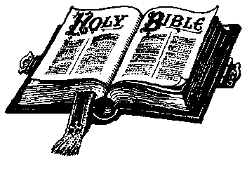
Holy Spirit received and faithfully handed on within the living Tradition and teaching of the Church.”
Religious Education Curriculum Directory

The children will learn that the Bible is a story of God’s love and concern for us. They will learn that the Bible is a living book through which God speaks to us and tells us about himself. They will learn that the Bible is one story told
through many different books and they will learn about Moses, David and Jonah as well as learning how to find a Bible reference.
The children will have the chance to:
• explore how the Bible helps us to pray and experience how God speaks to us in the Bible
• participate in a liturgy and experience a guided meditation on a text from the Bible

At home
You could help your children by:
• reading some of the stories the children have covered in class

Year 5 – Gifts from God
“Each human person is unique and made in God’s image and likeness”
Religious Education Curriculum Directory

The children will learn the story of Creation and the Fall in the Book of Genesis. They will learn that we are all created in the image and likeness of God and know that God calls us to care for others and all creation with love and respect. They will learn that there are times when we fail to be good stewards of creation. They will also learn that there are people who show great respect for creation and for the weakest members of society.

The children will have the chance to:
• appreciate how we can show respect for ourselves, for others and for God.
• reflect on times we have failed to show respect and reflect on the gifts and talents God has given each of us.
• reflect on the use and misuse we can make of these gifts.

At home
You could help your children by:
• talking to the children about how they could care for creation and the environment

This half term Year 6 could be taught the unit on the Kingdom of God or the unit entitled Called to Serve

Year 6—Kingdom of God
“Instead, be concerned above everything else with the Kingdom of God and with what he requires of you, and he will provide you with all these other things.” (Matthew 6:33)
The children will be introduced to Jesus’ teaching about the Kingdom of God; a teaching central to his life and mission. They will be taught the concept of the Kingdom of God through some of the parables and miracles of Jesus and will explore the ways in which people respond to Jesus’ invitation to belong to his Kingdom.
The children will have the chance to:
• reflect on what the Kingdom of God is like and is not like
• understand some of the parables of the Kingdom
• reflect on the importance of responding to the invitation to the Kingdom
• reflect on the words and deeds necessary to show commitment to the Kingdom
•know there are three kinds of miracle
• know that Jesus’ miracles reflected the beginning of the Kingdom and show us what God is like

At Home
You could help your children by:
• asking them to explain the meaning of the Kingdom of God
• discuss the parables and their meaning
• read a miracle story and discuss what it tells us about God

Called to Serve
“The gifts of the Holy Spirit enable us to share the mission of the Church.”
Religious Education Curriculum Directory

The children will learn about Jesus’ teaching and example of service of others. They will develop their ability to recognise that God has given us all gifts and talents to use in the service of him and his people. They will learn about the gifts of the Holy Spirit and understand that we receive these gifts in a special way through the Sacrament of Confirmation.
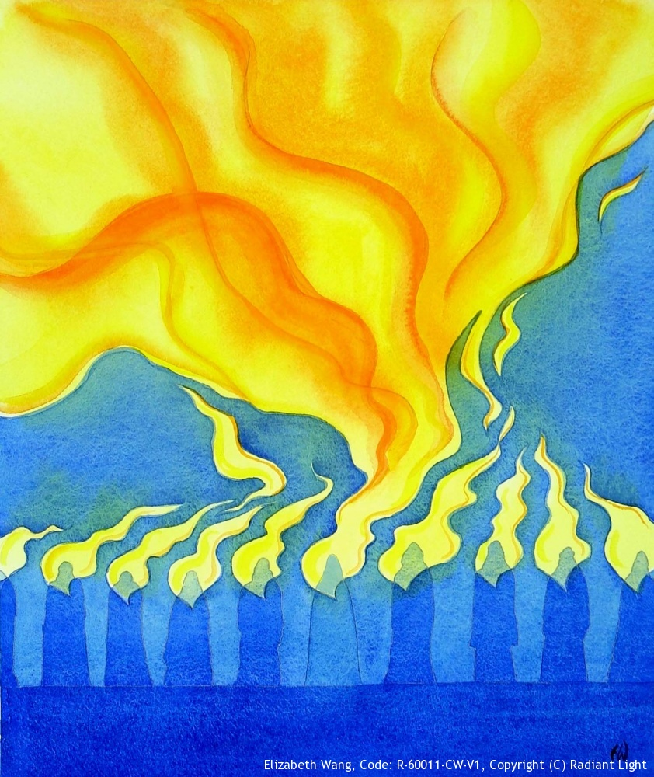

The children will have an opportunity to:

• reflect on the Sacrament of Confirmation and the commitment
necessary of a Christian
• reflect on a life of service

At Home
You could help your children by:
• discussing the importance of the gifts of the Holy Spirit and the Sacrament of Confirmation
•discussing the many ways in which we can be called to serve God and our neighbour
▪ chatting about their gifts and talents, both obvious ones and hidden ones

