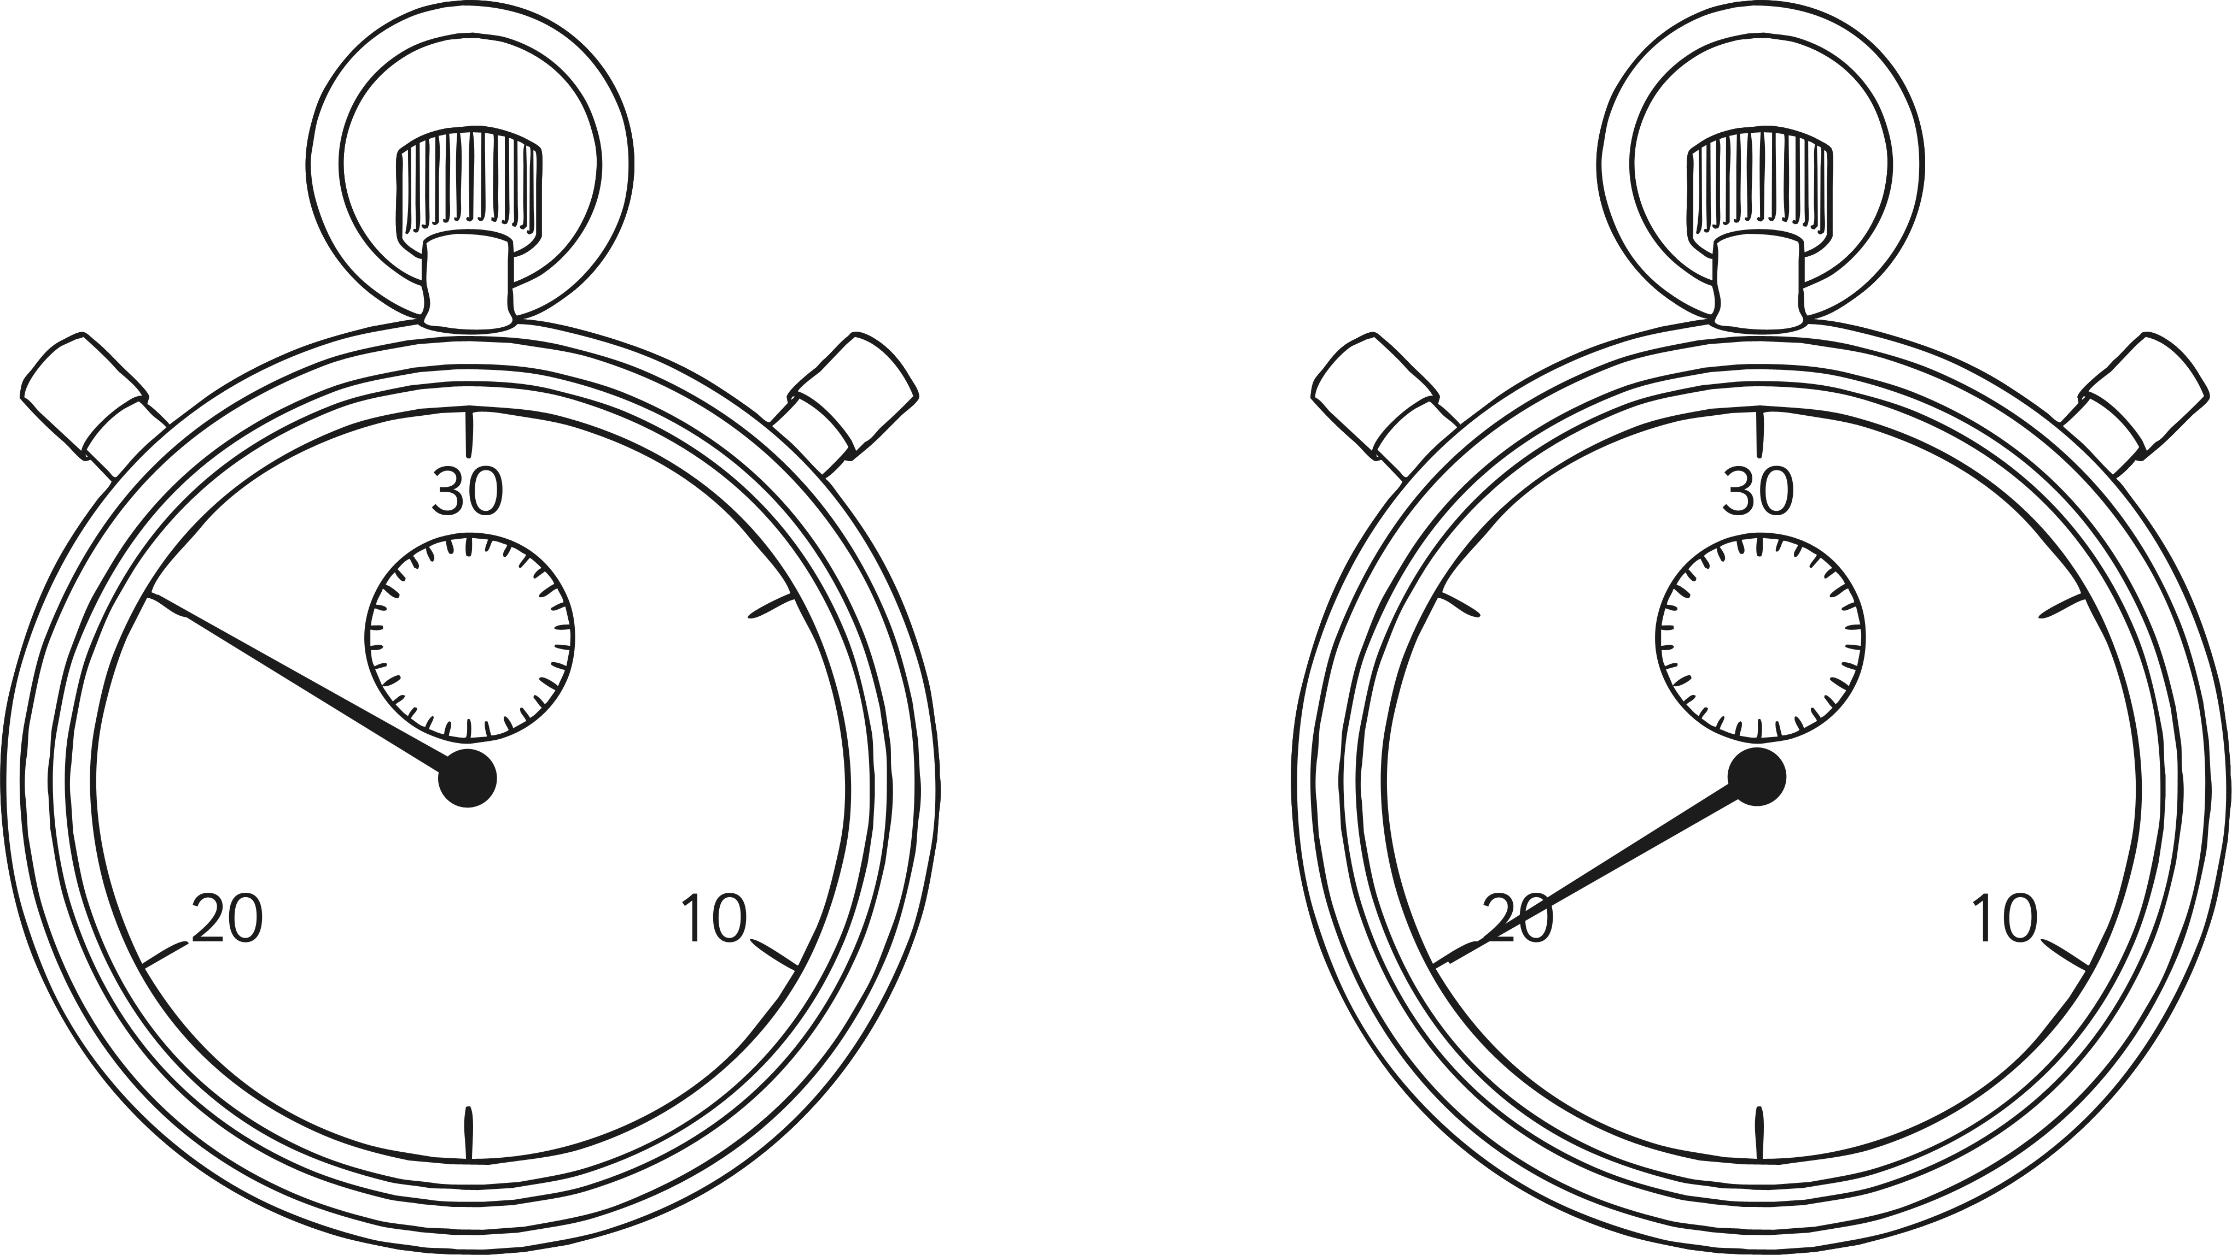
Beat the Clock
Score: _____________ Time: _____________

x | 3 | 4 | 8 | 5 | 10
4
2
6
12
3
7
1
5
11
10
9
8

My target for next time is


Maths | Year 3 | Multiplication and Division | Multiplication | Lesson 2 of 4: The Grid Method

